**Assignment 9B**

MKT 441-75 | Due: 11/20/17

Cailyn Cochran | Paige Ezell | Brevin Woodford

**\*All group members contributed equally to this assignment\***

# Marketing Research

# Assignment #9b

# 25 Points

### For this assignment, use your formatted/coded data set (i.e. after you removed the respondents who failed one or more quality checks)

### 

Please complete the following steps related to the analysis of your formatted data file. This assignment should be completed in **SPSS**. **Cut and paste the SPSS results into WORD for each question.**

1. Double check that you are using your most current, up to date spreadsheet that only exams the number of respondents that have passed all of the quality check questions.

Does the sample size for your current spreadsheet match the sample size from Assign 8 and #9a for number of respondents who passed all of the quality check questions (Yes or No).

**Yes**

What is the number of respondents who passed all of the quality check questions (type the number below)

**743**

2. Create a simple perceptual map in either **XL** or SPSS (but different from the one in the prior assignment). On this perceptual map, please plot both Powerade and Gatorade on two attributes you think are important. The easiest way to do this is with an XY (or scatter) graph in XL.

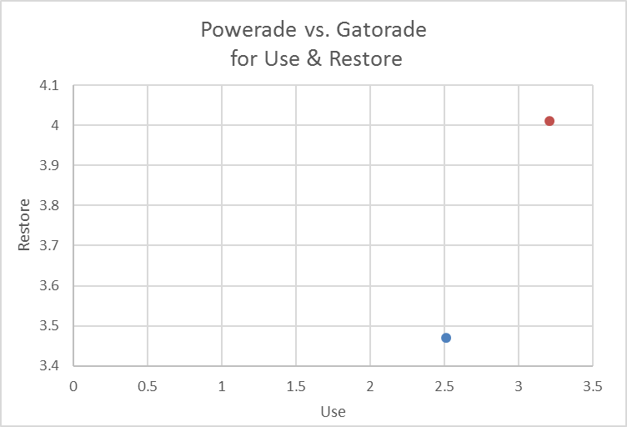

3. Create a single (easy to read) pivot table that shows the average awareness of Gatorade compared to powerade. Your pivot table should include sample size. Remember to use your work from prior assignments.

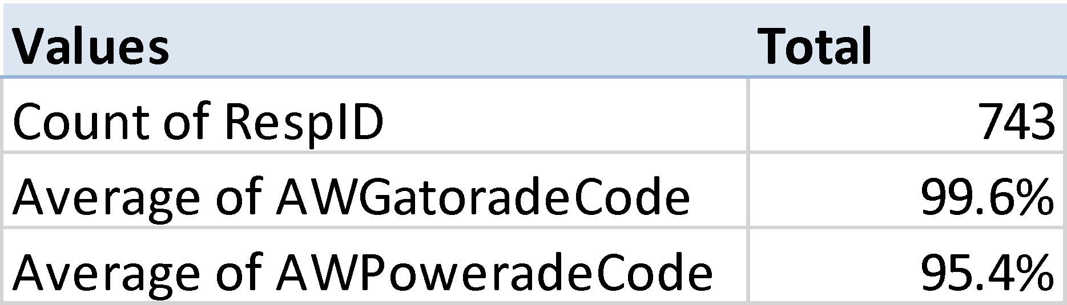

4. Create a single (easy to read) pivot table that shows the average bottles consumed of Gatorade compared to powerade (based on your re-coded data). Your pivot table should include sample size. Remember to use your work from prior assignments.

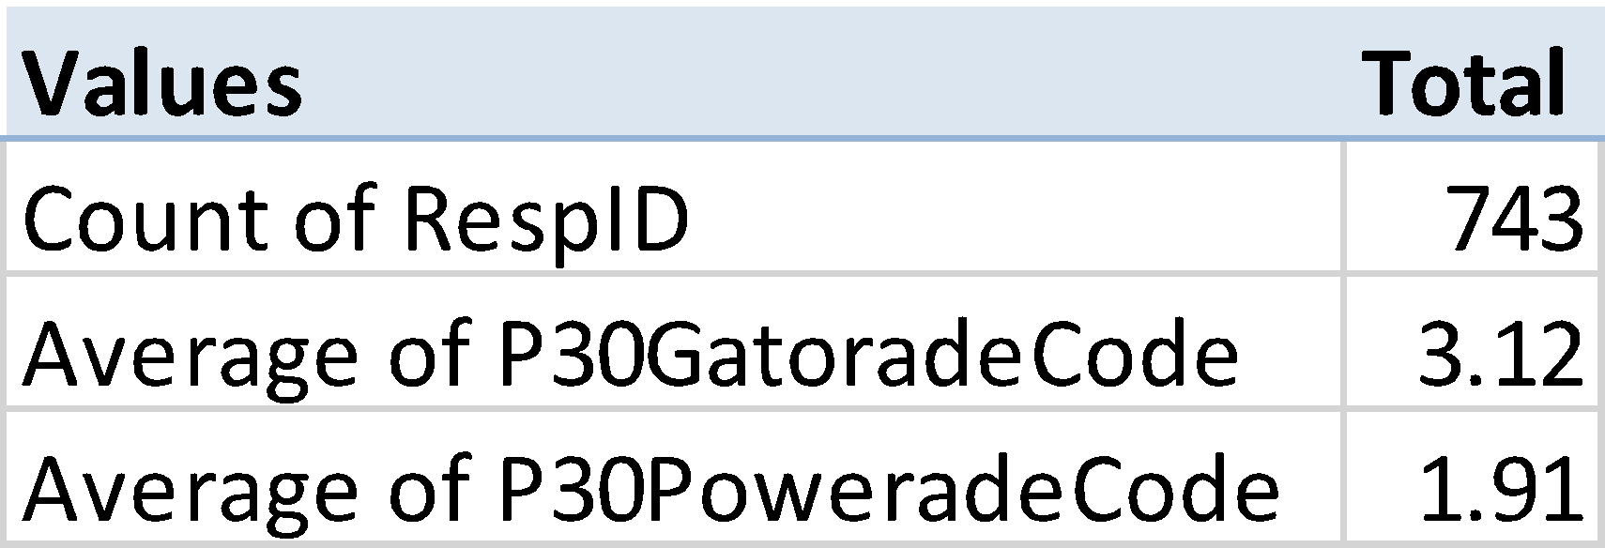

5. Conduct a hypothesis test by comparing the awareness levels between Powerade and Gatorade using *analyze/compare means/paired sample t-test* in SPSS. **Be sure to show the details including the MEAN RATINGS. W**hat is the null hypothesis? what is the alternative hypothesis? Based on the results, do you accept or reject the null hypothesis? Why?

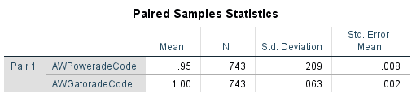

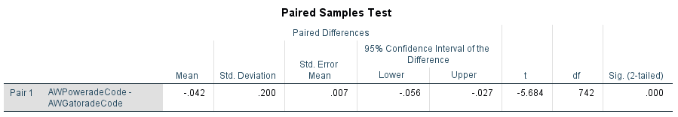

**Null Hypothesis:**

**There is no difference in mean between the awareness of Powerade and Gatorade.**

**Alternative Hypothesis:**

**There is a significant difference in mean between the awareness of Powerade and Gatorade.**

**Based on our results, we reject the null hypothesis. The Sig (2-tailed) test shows a value of .000, meaning we are essentially 100% sure that there is in fact a difference in the mean between the awareness of Powerade and the awareness of Gatorade.**

6. Conduct a hypothesis test by comparing the past 30 day usage (i.e. the re-coded NUMBER of bottles consumed) between Powerade and Gatorade using *analyze/compare means/paired sample t-test* in SPSS **using the data you RECODED** using the 13 nested =IF statement. **Be sure to show the details including the MEAN RATINGS. W**hat is the null hypothesis? what is the alternative hypothesis? Based on the results, do you accept or reject the null hypothesis? Why?

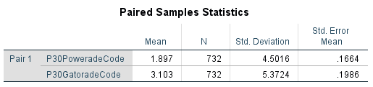

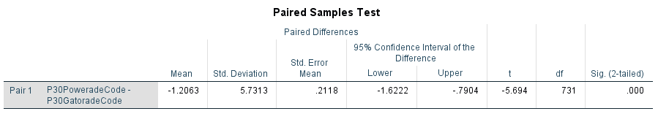

**Null Hypothesis:**

**There is no difference in the mean between the bottles of Powerade and Gatorade consumed in the past 30 days.**

**Alternative Hypothesis:**

**There is a significant difference in the mean between the bottles of Powerade and Gatorade consumed in the past 30 days.**

**Based on our results, we reject the null hypothesis. The Sig (2-tailed) test shows a value of .000, meaning we are essentially 100% sure that there is in fact a difference in the mean between the bottles of Powerade and Gatorade consumed in the past 30 days.**

7. Think of the issues facing Powerade. While our homework questions have addressed some of their issues, others remain to be answered.

Please conduct an analysis and create a graph or presentable table to address an issue for Powerade that we have not specifically gone over in the homework. This can be completed in XL and/or SPSS. This will be important way to distinguish your presentation (and WOW! the client).

**This extra analysis should be either a hypothesis test, regression analysis (based on the approach you learned in Bus Stats), or perceptual map.**

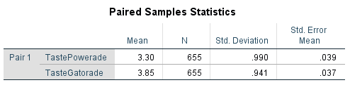

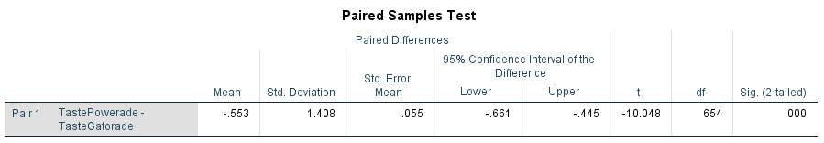

**Null Hypothesis: There is no difference in the mean between the consumer perception of the taste of Powerade and the consumer perception of the taste of Gatorade.**

**Alternative Hypothesis: There is a significant difference in the mean between the consumer perception of the taste of Powerade and the consumer perception of the taste of Gatorade.**

**Based on our results, we *reject the null hypothesis*. The Sig (2-tailed) test shows a value of .000, meaning we are essentially 100% sure that there is in fact a difference in the mean between the consumer perception of the taste of Powerade and the consumer perception of the taste of Gatorade.**

8. Now, repeat prior question, but for a different Powerade issue.

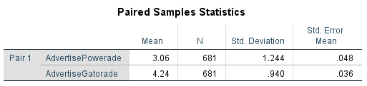

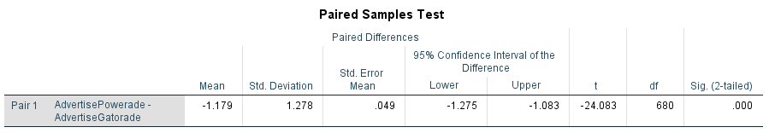

**Null Hypothesis: There is no difference in the mean between the consumers who see advertisements of Powerade on television and the consumers who see advertisements of Gatorade on television.**

**Alternative Hypothesis: There is a significant difference in the mean between the consumers who see advertisements of Powerade on television and the consumers who see advertisements of Gatorade on television.**

**Based on our results, we *reject the null hypothesis*. The Sig (2-tailed) test shows a value of .000, meaning we are essentially 100% sure that there is in fact a difference in the mean between the consumers who see advertisements of Powerade on television and the consumers who see advertisements of Gatorade on television. Although NOT due as part of this assignment, you should start thinking about the recommendations you have for Powerade and the financial impact (i.e. breakeven and ROI) related to your suggestions (it will be part of the next assignment and the final report/presentation)**

1. Based on your analysis of the problem(s) confronting Powerade, what is a reasonable new marketing activity for the company to conduct to help increase sale (Note: this does not have to be your final recommendation for Powerade – although it could be - but it needs to be a reasonable recommendation).
2. What is the cost for this new marketing activity?
3. If Powerade follows your recommendation, by how much will sales increase (from the current base level you provided in a prior question)? This will, of course, involve assumptions, but you must provide logical support for your assumptions. This will also be good practice for MKT 460.
4. What is the ROI of your recommended marketing activity for Powerade? Be sure to only examine the *incremental* sales and the *incremental* marketing spending.
5. What is the Breakeven timing of your recommended marketing activity for Powerade?